Hello guys, This is the ‘SAVE THE BALL GAME’ made by my team- SoloPlayer

**Team Member :-**

1. PIYUSH BHATNAGAR (21103186)

HOW TO PLAY GAME:-

1. Open the index.html file and there will be a alert which shows the max score for the game till now.

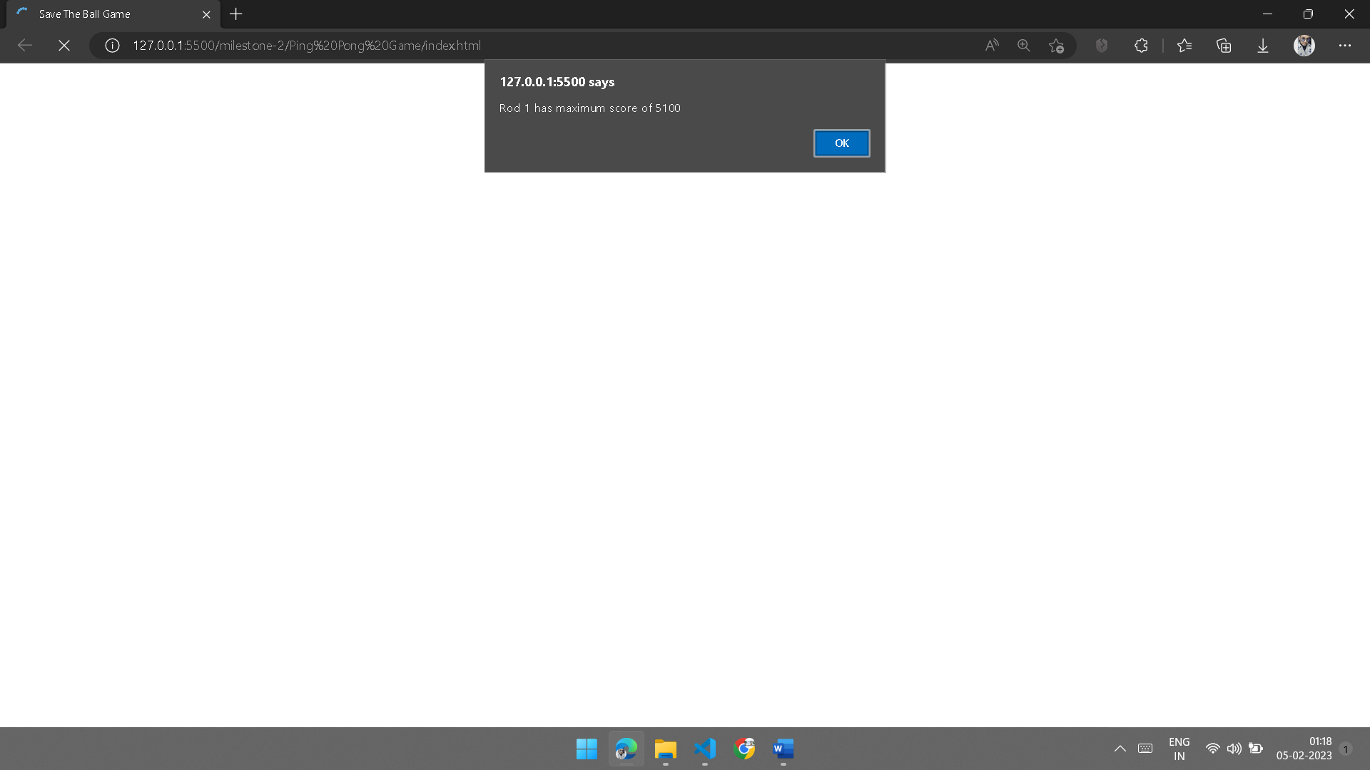

1. Then next alert shows the Instructions for the game.

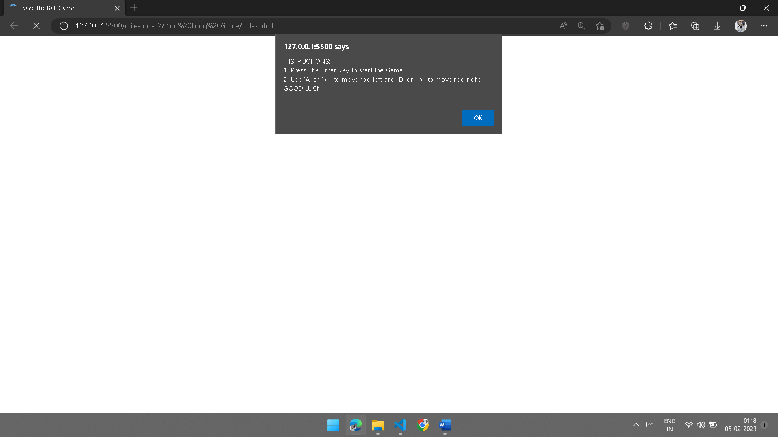

1. Then you will see the game page. Press Enter to start the game. Use either arrow keys or ‘A’ and ‘D’ to move the rods left and right.

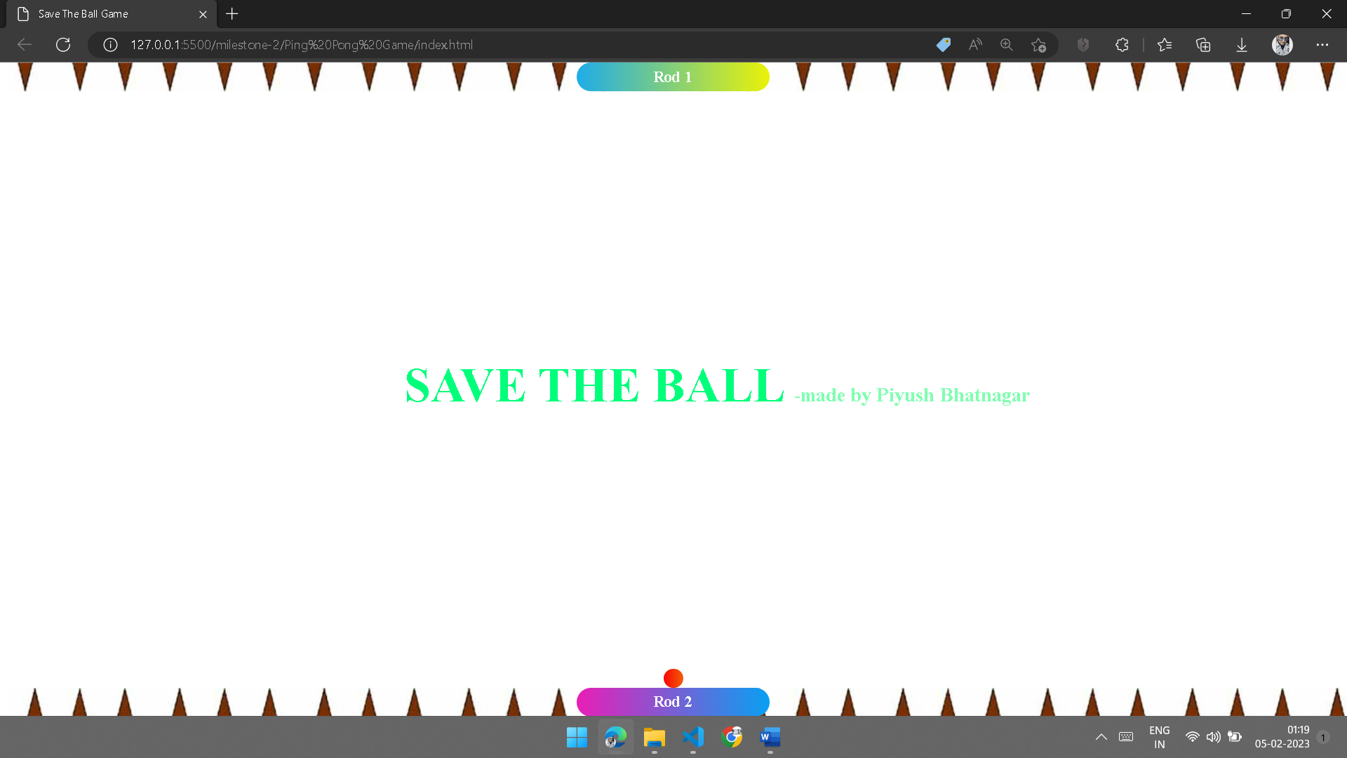

1. Save the ball from hitting the spikes

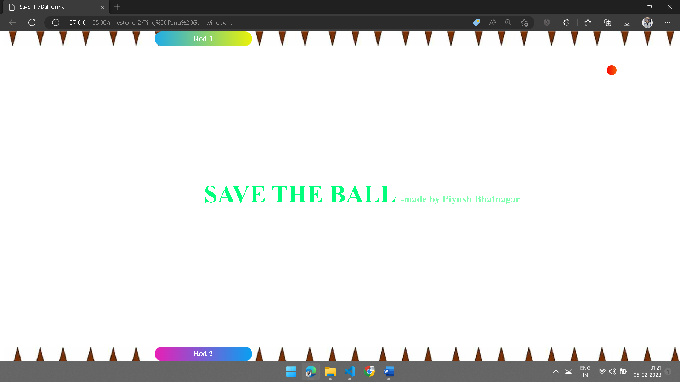

->You will see which rod **wins** and with how much **score** when the other rod can’t save the ball and ball hits spikes.

**ENJOY THE GAME !!**

**THANK YOU**